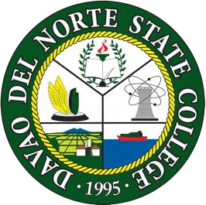
BOOTCAMPUTERSHOP

DAVAO DEL NORTE STATE COLLEGE
New Visayas, Panabo City

A Final Project submitted by:

Pantonial, John Kenneth R.
Orga, Cyrelle Khen D.
Juntilla, Zyrou V.
Villarente, Gian J.

MAY 2024
INTRODUCTION
Internet café is not really about computers only; it is about people, communication and sharing information and knowledge as well as overcoming physical boundaries. While the internet cafés offer access to tremendous education, leisure, and social opportunities through internet, on the negative side, as more and more computers are connected to the internet, the networks are becoming more vulnerable, making it easy for an intruder to attack systems in many ways. (1)

A computer shop is a place where one can use a computer with internet access, but it has fees, usually per hour or minute. In the Philippines, computer shops are found on every street in major cities and there is at least one in most municipalities or towns. There are also computer shops or Internet cafes in coffee shops and malls but most of it are near at school premises because we all know that nowadays many people like students are in need of computer to browse or to have an easiest way to get information they need and to make assignment and etc. Computer shops become popular because anyone can afford to rent with it. Internet connection then was dial up and relatively expensive therefore only a few shops offered internet service. The bulk of service back then was gaming and typing services for students.

OBJECTIVES.
To establish a server for an internet cafe business.
The developers aim to develop a computer shop server for internet cafe business to any parts of Panabo City.
Specifically the project aims to:
- Ask the user to register an account and input their details:
- Full Name
- Password
- Amount
- Let the user to log in the registered account.
- Display the details and time remaining of the user in the admin page.
- Let the admin Update/Delete the account.
DATABASE DESIGN
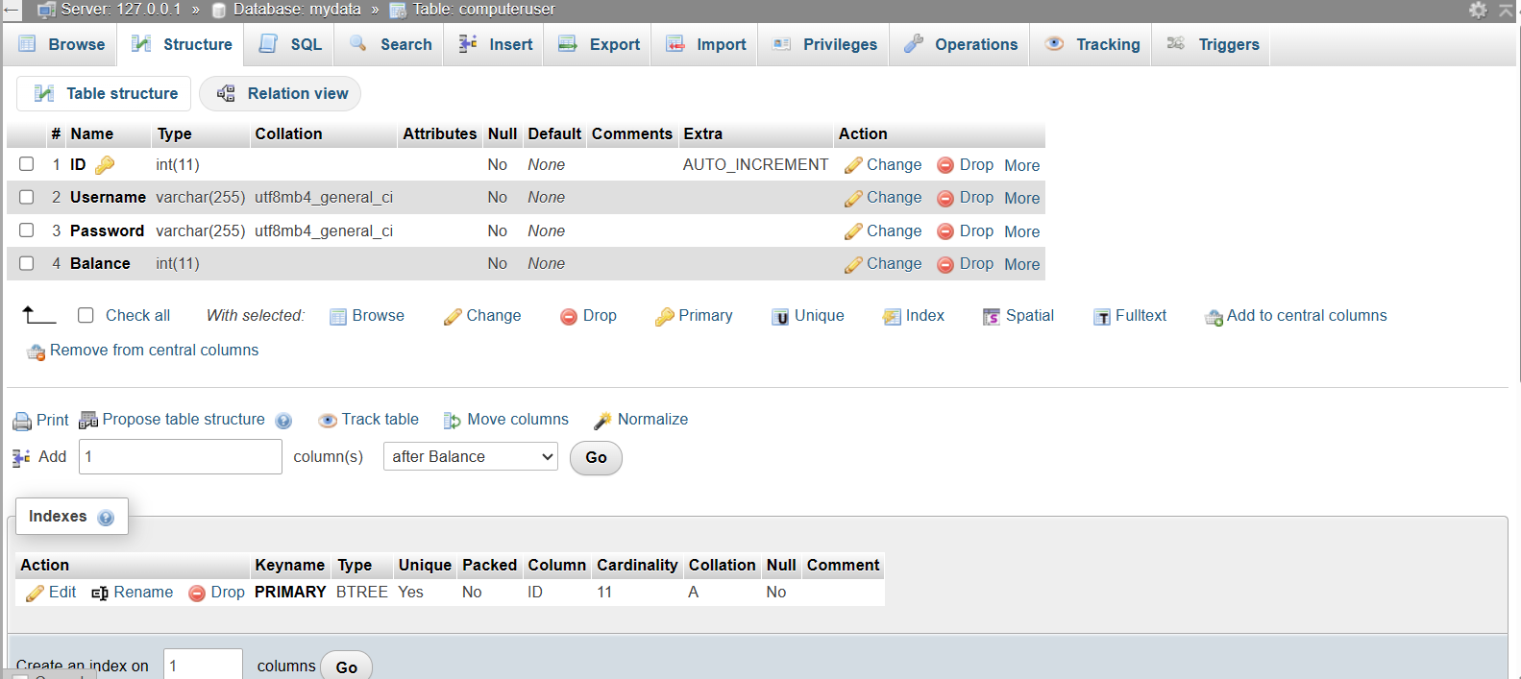
Our database is used to store the data of users that is registered by the admin, our structure only uses varchar and int data types. There are 4 columns in our Table(computeruser): first is the ID which uses data type int and is auto incremented, second is the Username which uses varchar datatype with a character limit of 255characters, third is the Password that also uses the varchar data type with a character limit of 255characters and lastly is the Balance that uses the data type int and has a limit of 11 characters.

Table 1: Database Structure of our BOOTACAMPUTERSHOP System

Table 1 shows the data of the users that will be registered by the admin.

SYSTEM’S FLOWCHART
This figure shows the flow of our system starting from log in of the admin and registration of a new user.
Example:
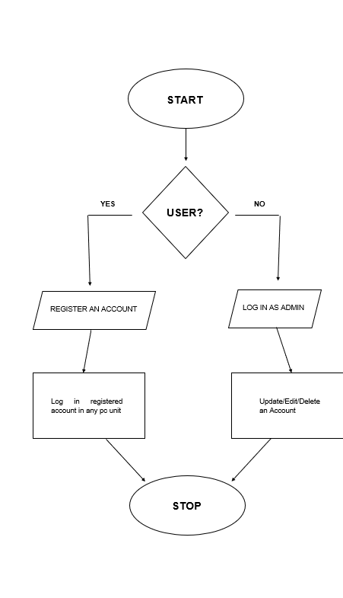
Figure 1: Flowchart of BOOTCAMPUTERSHOP System
Figure 1 shows the system’s flowchart of [BOOTCAMPUTERSHOP] where the admin logs in and register a new user and after the user had successfully registered his/her account, he/she can freely choose where to play and it lets the admin to see and update the users remaining time. The admin can also update and edit the details of the user and can also delete an account if the user wants it to be deleted.
REFERENCES

- JULIUS CESAR O. MAMARIL, Computer Security Analysis of Internet Cafés in Philippines, Volume 1, Panagsinan State University, Mamaril,2016.

